# SWBSTATS program operation

SWBSTATS allow users to process SWB output by accessing the *.bin files that are created by SWB during a model run. Requesting any output for a SWB variable will result in the generation of a binary file that may be accessed by the SWBSTATS program.

For example, in order to generate a binary output file for the variable “RUNOFF_OUTSIDE”, the following directive could be included in the SWB control file:

OUTPUT_OPTIONS RUNOFF_OUTSIDE NONE NONE PLOT

By default, SWB will write the binary files to a subdirectory called “output,” one level beneath the directory where SWB was executed.

| Command-line option | Description | Notes |
| --- | --- | --- |
| GRID | PLOT | BOTH | STATS | Output type | Select ASCII grid or plot for output. Alternatively, select a statistics table for output. Mutually exclusive. “BOTH” selects both grid and plot output types. |
| YEARLY | MONTHLY | DAILY | Output frequency | Specify the time frequency for calculation and output. If no frequency is specified, output is summarized over the entire time period. |
| SUM | Output statistic | Calculate statistics based on SUM of values rather than MEAN values. This is often what is desired when summarizing potential recharge. |
| VERBOSE | Output log | Write daily min, mean, and max values to logfile. |
| SURFER | Grid type | Direct output to Surfer grids rather than Arc ASCII grids. |
| MASK {mask file name} | Mask statistics | Specify a *single* mask file; stats are calculated for each cell for which the mask file contains an integer greater than zero. If the mask file contains more than one value greater than zero, the statistics will be calculated for each nonzero integer value in the mask grid. |
| MASK_SSF {mask file name} {SSF site ID} {grid cell value} | Mask SSF statistics | Specify a single mask file; generates a PEST site-sample file (*.SSF). User must specify a site label or id, and a mask value which must be met in order for the grid cell to be included in the calculation. |
| CUMULATIVE | Output statistic | Specify that MASK statistics are cumulative; these cumulative statistics are reset at the beginning of each year. This could be used, for example, to output a running sum of potential recharge over the course of a year. |
| PERIOD_SLICE {start mm/dd} {end mm/dd} | Subset time slice | Calculates stats on a specified subset of days each year. For example, 'PERIOD_SLICE 06/01 08/31' will report stats for the subset of output that occurs between June 1st and Aug. 31st of each year. |
| {start mm/dd/yyyy} {end mm/dd/yyyy} | Subset time range | Limit calculations to the values that fall within the start and end dates as specified. |

# Command-line options

Issuing the command **swbstats** with no arguments will cause it to print out some basic information regarding the program, including the compilation date and compiler used to create the executable you are running:

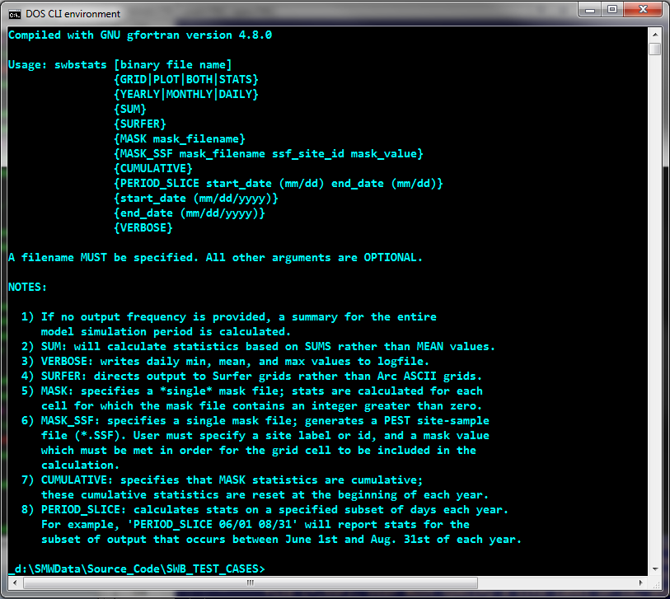

Issuing the command **swbstats** along with the name of a SWB binary file will cause the program to spit out details about the data contained in the binary file:

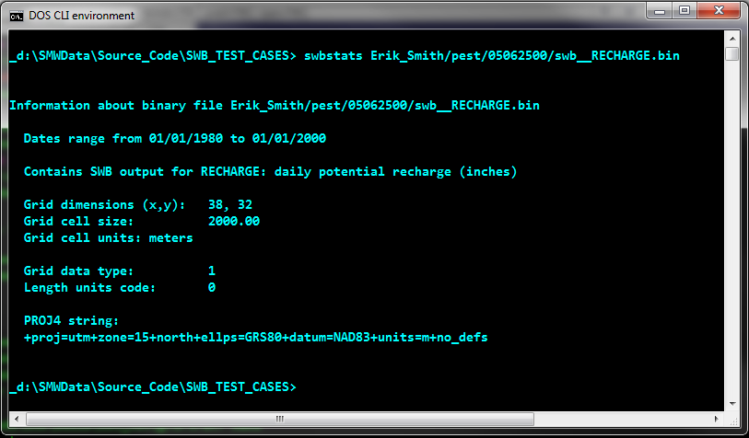

# Examples

## Annual sum of mean daily recharge, extracted by masked area:

swbstats Erik_Smith/pest/05062500/swb__RECHARGE.bin STATS ANNUAL SUM MASK Erik_Smith//observation_data/bfi_watershed_masks/05062500.asc

output:

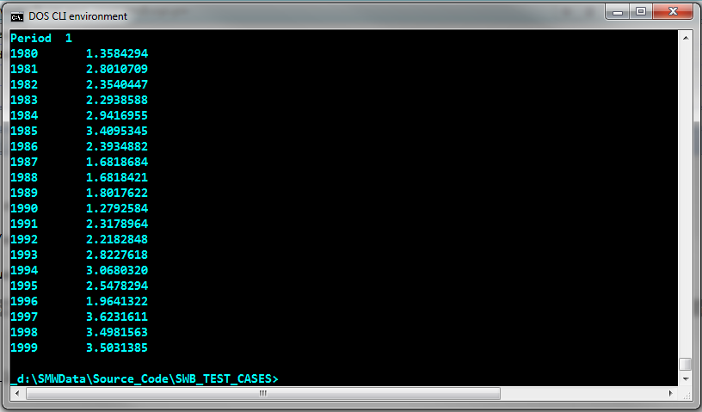

In the output file shown above, “Period” refers to the time period associated with the statistic; the integer value “1” was the only integer value greater than zero found in the maskfile.

If a mask file has multiple non-zero values, statistics will be calculated for each. For example, a summary of recharge by land use code is possible if the land use grid file is substituted for a mask file:

swbstats Erik_Smith/pest/05062500/swb__RECHARGE.bin STATS ANNUAL SUM MASK Erik_Smith/input/soils_hyd_grp.asc

output:

